Main Program Specifications for ABC Asset Management Fund Fact Sheet Generator
Project ID
Project Name | ABC Asset Management Fund Fact Sheet Generator
Account
Business Unit / Global Account
Project Manager
Document Version Number | 1.0.0
Approved by:

Revision History
Version Number | Release Date | Description of Change/s made | Author  (Name & Role) | Reviewer  (Name & Role) | Approver  (Name & Role)
 | Mmm-DD-YY

Table of Contents
Revision History 2
1. Program Description 4
1.1 Unit Name, Version and Language used 4
1.2 Unit Description 4
2. Input Specifications 4
2.1 Files/Tables 4
2.2 Screen Layouts 4
2.3 Parameters Passed 4
2.4 Validations 4
3. Process Specifications 4
3.1 Program structure chart 4
3.2 Pseudo code 4
4. Output Specification 5
4.1 Files/Tables 5
4.2 Screen Layouts 5
4.3 Report Layouts 5
4.4 Parameters Passed 5
4.5 Output formatting 5
5. Performance 5
6. Security 5
7. Reuse or Third-party component 6

Program Description

Unit Name, Version and Language used

Unit Name: Main
Language used: C#

Unit Description

The program unit will allow the user to navigate to different pages. He is able to access past history or edit fund details.

Input Specifications

Files/Tables

main
Field Name | Data type | Size | Constraints | Remarks
date | Date |  | Primary Key | Composite
ISIN | Varchar | 50 | Primary Key | Composite
NAV | Decimal | 18,2 | Foreign Key
offer | Decimal | 18,2
benchmarkPrice | Decimal | 18,2

Screen Layouts
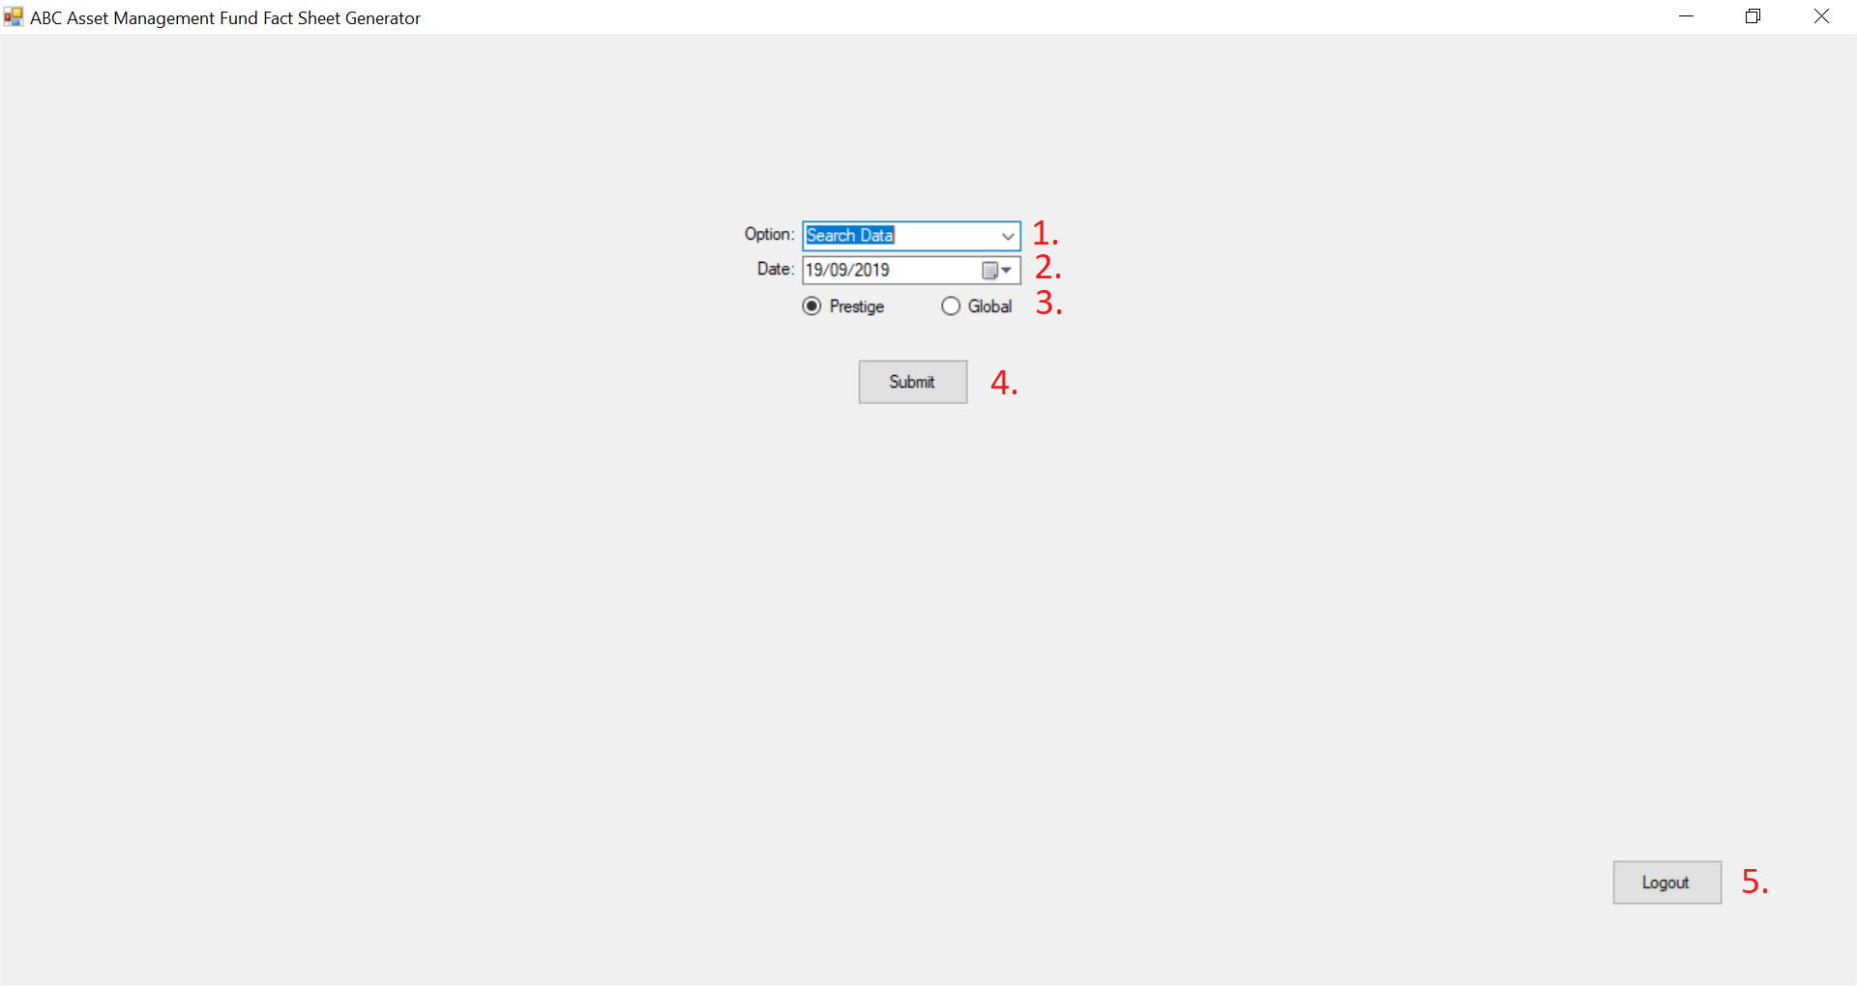

Parameters Passed

    - There will be a drop-down button allowing the fund manager to choose between “Search Data”, “Edit Fund Details” and “Edit Investor’s List”
    - This option will only appear if the fund manager chooses “Search Data”. The fund manager will be able to key in the desired data either through typing in the box or by clicking on the calendar icon. A calendar will pop out should this option be chosen.

Validations.

    - There will be a radio button allowing the fund manager to choose between “Prestige” and “Global”. If neither was chosen, an error message will pop up.
    - After keying all the fields, the fund manager will be able to click on submit to enter the desired page. A pop-up will appear if entries are invalid or data was unavailable for the specified date.

Process Specifications

Program structure chart

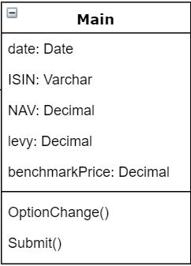

Pseudo code

OptionChange {
If (SelectedOption == “Search History”)
{ Display date picker option }
}

Submit {
If (SelectedRegion == “Prestige”)
{Region = “Prestige” }
Else
{Region = “Global” }
If (SelectedOption == “Search History”)
If (Date == ValidDates)
{go to Search History on Selected Date}
Else
{“Date is invalid” }
Else
{go to Edit Fund Details}
}

Output Specification

Files/Tables

Screen Layouts

Edit Fund Details Page

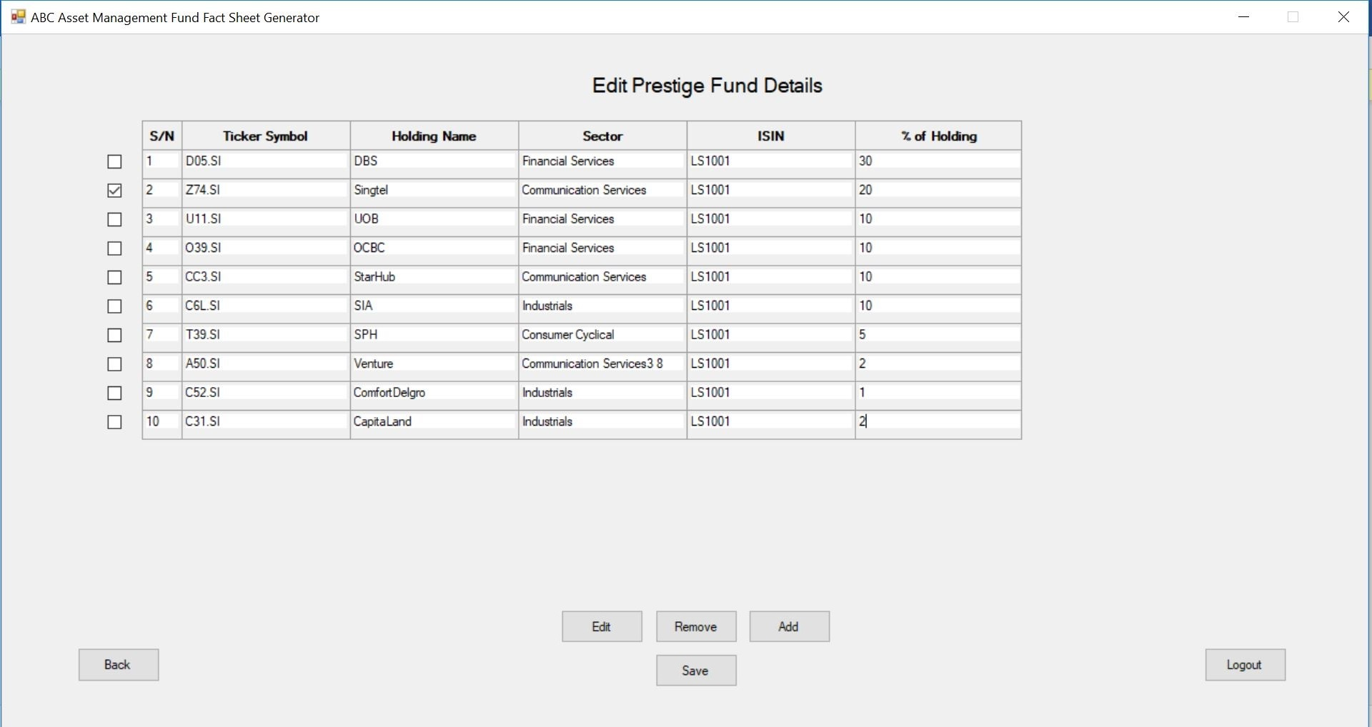

Search Data Pages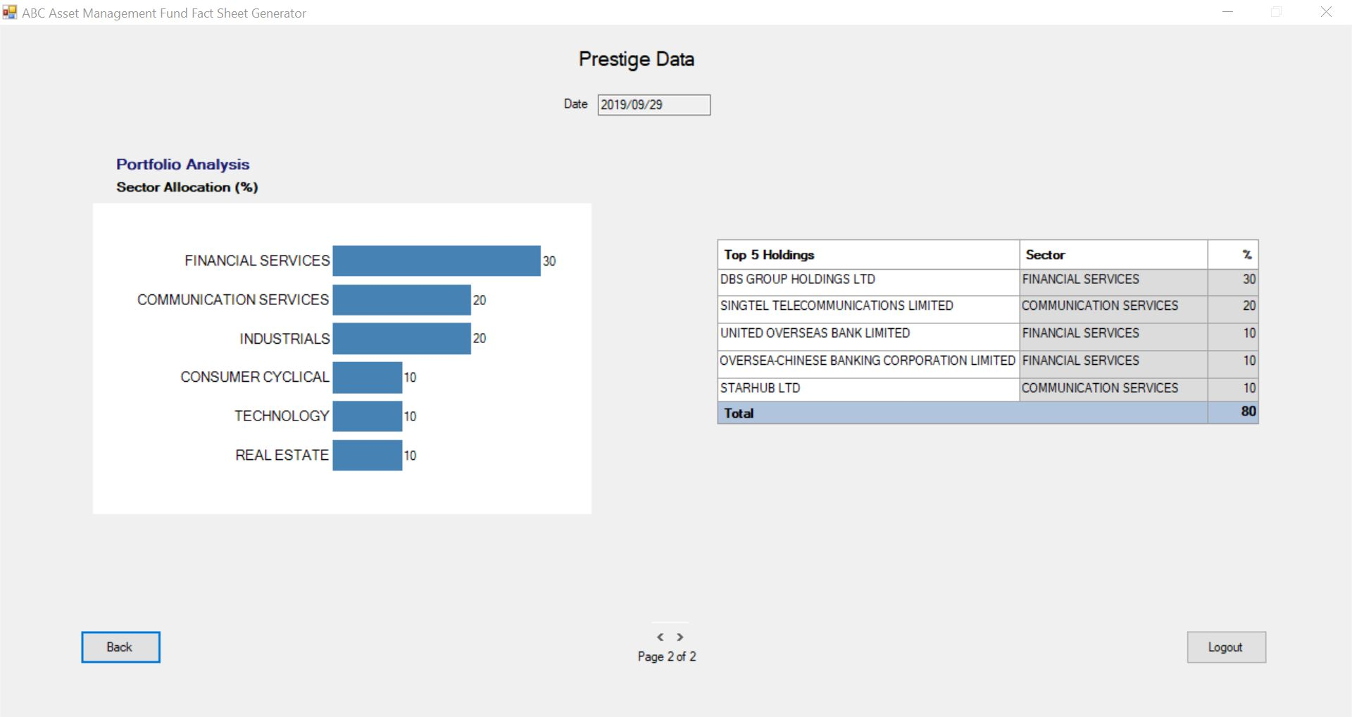

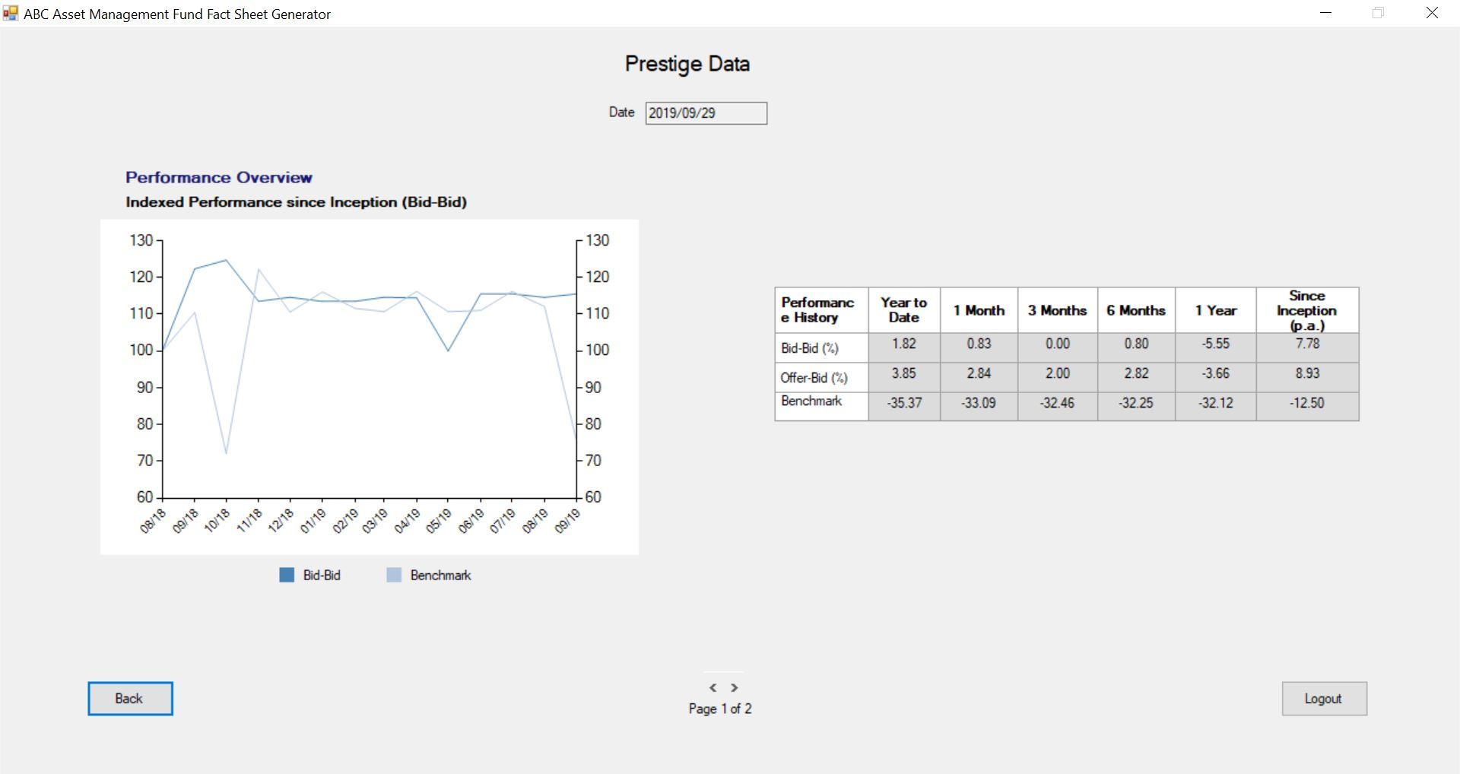

Edit Investor’s List Page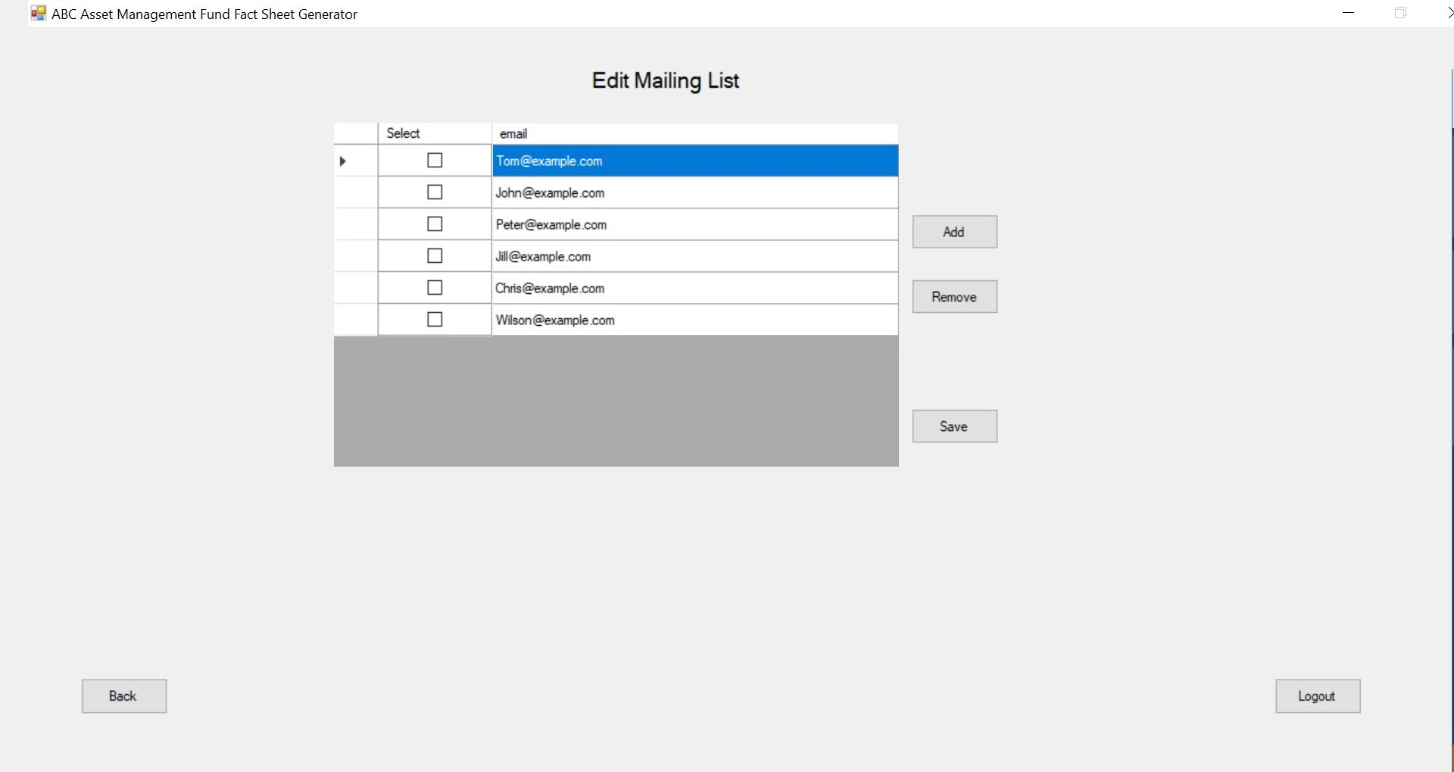

Report Layouts

Parameters Passed

Output formatting

Performance

Performance Requirements | Design | Constraints
Search Data History Validation | Only Valid Dates are allowed
Region Validation | One region must be chosen

Security

Application Areas | Identify special transactions and areas requiring Encryption
Application Data | Identify data that requires Encryption
Encryption in Transit/Storage | Identify need for Encryption while data transfer or storage
Encryption Policy | State the policy that governs Encryption

Reuse or Third-party component

[The identified reuse or purchased components, the modules in which these components are used and the assumptions and constraints in using these components can be filled in below table]

External component | Module impacted | Assumptions and Constraints | Source/License

Template Revision History (For EPEX Use Only)
Version Number | Release Date | Description of Change/s made | Author  (Name & Role) | Reviewer  (Name & Role) | Approver  (Name & Role) | QMS Release Version
1.0 | NA | Initial baseline | NA | NA | SEPG | NA
2.0 | Jun-14-11 | Assigned artifact id, version #, release date to the template and modified Information Classification label in the footer | Shreevidhya Srinivasan, PM | Radhika Seenivasakan, SEPG | Rajesh Sreekumar, SEPG | 4.2
2.1 | Nov-30-18 | Modified SEPG references to EPEX as a part of Re-Org | Prakash Palaniswamy, EPEX | Pradeep Kumar Pullathil, HEAD, EPEX | Pradeep Kumar Pullathil, HEAD, EPEX | 7.5

